Skills Guide

Video guide can be found here:

Last Updated : Y2025 - M07 - D06

Skills
Skills are tech that can be used by agents, they come in a variety of forms, as some are for dealing damage, while others are for crowd control and/or utility, all agents get 2 skill slots and can change their skills at any time, and also save them with their loadouts.

They come in 11 Types, with almost all Types having several Variants. With a total of 41 different Variants available in total.

Skill Tiers
Skills scale in power with skill tiers, each skill lists the stats that it has in the selection screen, together with what skill tier it has and what bonuses it receives from tiers.

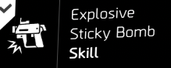  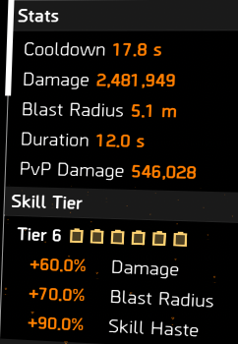 | 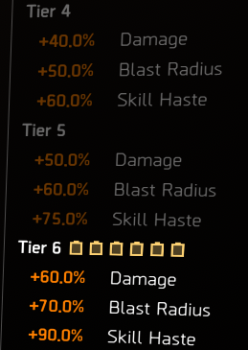

The stated amounts are at that specific tier added to the base stats, they are not additive per step. So for instance, if you have a tier 6 version of a skill, only the stats stated at tier 6 will be active bonuses.

Skill tiers will come mostly from cores on gear. Other places it can come from is the technician specialization giving 1 skill tier, certain brands (Brazos & Palisade) have it as a brand bonus, and the Tdi kard custom pistol can give 1 skill tier while held, amongst other temporary sources.

All the shields also will get a skill tier from blue cores, meaning they will scale up to 6 with any combination of yellow or blue.

The maximum skill tier is 6, even if you go over it it will not affect the skill beyond 6 tiers.

Overcharge
Overcharge is a special state that you achieve by fulfilling requirements of certain talents, overcharge will only activate once you have met the stated requirement of a talent and will put you on a cooldown timer tied to that talent afterwards.

The ways to overcharge are the BTSU gloves, Future Perfect, Energize and the Acosta Backpack. each has their own requirements, and all but the BTSU glove require you to be at skill tier 6 to activate overcharge.

Future perfect can take you from 3 skill tiers to overcharge, with 3 kills (or 4 kills from skill tier 2 for perfect), and Btsu will overcharge you at any tier including not having any skill tiers.

The BTSU has also a group wide overcharge, that I call supercharge, for the supercharge you do need to be at skill tier 6.

Below is a list of what skills will get what effects from being overcharged :
- Smart Covers : Increased radius and effects.
- Sticky Bombs : Increased radius, effects and/or damage. Fire sticky also gains a massive amount of skill haste.
- Traps : Increased radius, effects and/or damage. Repair traps also apply status effect immunity.
- Decoy : Increased threat and health.
- Pulses : Increased radius and effects. Scanner and Remote will apply a 15% damage debuff to enemies pulsed. Achilles marks all zones.
- Turrets : Increased health and effects and/or damage. Sniper and Artillery gain extra ammo charges
- Hives : Increased radius, drone flight speed, effects and/or damage. All hives gain a massive amount of skill haste. All hives gain an increased amount of charges.
- Chem Launchers : Increased radius, duration, effects and/or damage.
- Fireflies : Increased target amount, flight speed, effects and/or damage.
- Seekers : Increased radius, effects and/or damage. Airburst also gains massive skill haste.
- Drones : Increased health and effects and/or damage.
- Shields : Bulwark, Crusader and Striker gain active regeneration. Deflector gains damage. Striker also gains health, holstered regeneration and damage buff strength. All shields are invulnerable for the duration of the overcharge.

Skill Mods
Skill mods are items you can put into skill mod slots on skills, they have small bonuses, and are farmable as a separate targeted loot category.

Each skill has its own skill mods and they are specific to a certain slot, all skills have 2 or 3 mod slots.

They are per type and not per variant, meaning,for example, all hives share the same mods, and it will retain them when you go from stinger to restorer.
Skill mods are saved with loadouts as well.

Controls
Each skill is on its own button, per default Q and E on pc or the bumpers on controller, on pc this is rebindable, certain skills require multiple inputs to target them, and some also have special actions they perform on a double tap. Most notably the fire chem that for instance can be ignited by double tapping when the cloud is on the ground, or for the turret to instantly deploy it on top of the cover that you are in.

On PC there is also the option to bind the keys ‘Instant Use Agent Skill 1/2’, these allow you to instantly use the skill. For certain skills this is a very useful key to have bound and to use, as for instance with the sticky bombs, this can be used to instantly fire it, and you can aim it by using your weapons crosshairs.


The skills list their special controls at the bottom of the selection screen overview window.
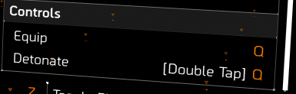

Acquiring Skills
Skill will be acquired while you are leveling through the base game, you are allowed to unlock new types after certain missions, letting you unlock a type by choosing a variant as the first unlock in that type.
once a type has been unlocked, then other variants in that type can be unlocked by using SHD tech that comes from SHD tech caches in the open world and certain missions and side missions

If you do all the side missions and collect all the caches then you will have more than enough SHD tech to unlock all perks and skills, so eventually you will have them all.

During the base game and world tiers, only 8 skill types are available, the other three come from WONY expansion.

Acquiring Certain Skills
6 variants will only unlock through specializations, getting through the wony expansion unlocks 3 new types with 4 variants total, and a further 4 variants are unlocked by obtaining them in manhunt climax missions.

Specialization : Each specialization has a skill tied to it, you must unlock it in the specialization tree, and the skill can only be equipped if you are running that specialization. In the list below they are highlighted in Blue.

Warlord of New York : During your WONY expansion playthrough, you will eliminate certain rogue agents and obtain their 4 signature skills. In the list below they are highlighted in Red.
Battle for Brooklyn : During your BFB expansion playthrough, you will join up with a certain rogue agent and obtain the Smart cover skill. In the list below they are also highlighted in Red.

Manhunt Climax Missions : The Climax missions of the manhunts of season 1-4 also each have a variant. To get these skills you need to have access to the climax missions, they are available by toggle-ing certain missions to manhunt.
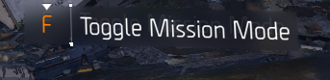

There is a ‘Legacy Manhunt' option in the Manhunt screen that can be used to know where to go.


Jupiter - Emp Sticky - Roosevelt Island
Hornet - Repair Trap - Tidal Basin
Bardon Schaeffer - Shrapnel Trap - Coney Island Amusement Park
Faye Lau - Achilles Pulse - Camp White Oak

In the list below they are highlighted in Magenta.

Smart Cover
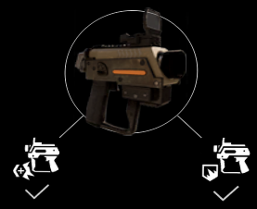 |   Handheld launcher that fires a sticky charge which can be fired from a distance and will turn that marked area into smart cover.  will be readied with the first button press and fired with a second.  Instant use or double tap can be used in cover to attach it to that cover, instant use while out of cover only pulls it out.
Precision Smart Cover | Players in cover inside the affected area receive Weapon Handling and Damage to Targets Out of Cover bonuses.
Fortified Smart Cover | Players in cover inside the affected area receive Bonus Armour, Explosive Resistance and Pulse Resistance bonuses.
Smart cover, especially the precision variant, is one of the strongest skills in the game, as it can greatly increase damage.

Sticky Bomb
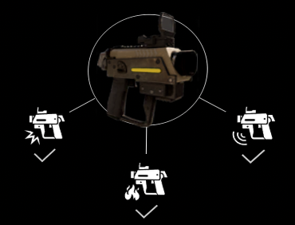 | 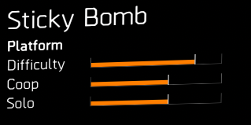Handheld launcher that fires a sticky charge which can attach to enemies.  will be readied with the first button press and fired with a second, once attached a single press will detonate the charge.  Instant use or double tap can be used to instantly fire at the center of the screen, you can use a weapon reticle for added precision.
Explosive Sticky Bomb | Deals explosive damage, damage scales with skill damage and explosive damage.
Burn Sticky Bomb  (Fire Sticky) | Applies fire, damage scales with status and skill damage, duration scales with status.
EMP Sticky Bomb | Applies disruption scales with status effect, deals electronic damage scaled with skill damage and status effect.
All stickies are useful, explosive sticky works well in explosive builds, fire sticky can be use for eclipse and status builds, emp sticky is good for eclipse and even full reds to disable mechanicals.

Trap
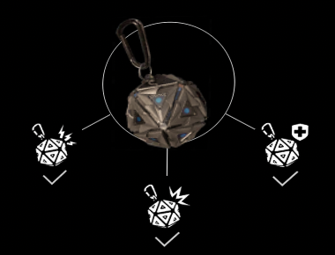 | 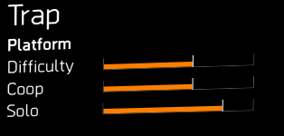Deployed in an area, and will be triggered by enemies/players entering a traps marked area.  Will be readied with the first button press and deployed with a second, when readied will show area of deployment and path of throw.  Instant use or double tap will deploy instantly at your location, deploying all around you.  Can affect the player that deploys it, if triggered by an enemy while in the circle.
Shock Trap | Deploys in a circle. Shocks enemies when triggered. Shock duration scales with status effect.
Shrapnel Trap  (Explosive Trap) | Deploys in a circle. Deals explosive damage, damage scales with skill damage and explosive damage.
Repair Trap  (Healing Trap) | Deploys in a line, Traps heal when triggered by player or allies. Heals scale with repair skills. While overcharged will also apply 100% hazard Protection.
Shock trap is useful for eclipse. Shrapnel and repair traps are not generally very useful.

Decoy
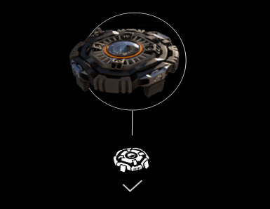 | 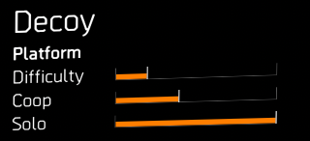Deploys a decoy that will draw enemy fire.  Will be readied with the first button press and then thrown with a second, when readied has an overlay for where it will land.  Instant use or double press will deploy at your feet.
Holographic Distraction Decoy | Deploys a holographic decoy to draw enemy fire, duration scales with skill duration.
Decoy is great for red builds to draw aggro away from them.

Pulse
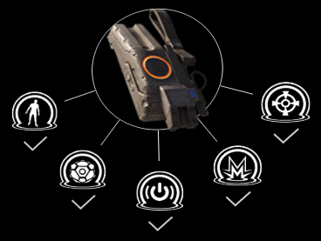 | 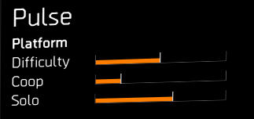Skill type with varying variants, some triggered some deployed.  Some have special controls that charge while the button is held.
Scanner Pulse | Pulses enemies to reveal them to player and allies, button press triggers activation.
Remote Pulse | Deployed skill that is readied with the first button press and thrown with a second, deploys on the ground and pulses in intervals, applying pulse to enemies.
Jammer Pulse | Charges on held button press, and requires the button to be held for full radius. Disrupts enemies in a circle around the player. Disruption duration scales with status effect
Banshee Pulse | Charges on held button press and requires the button to be held for distance. Starts charging with a short and wide cone and becomes more narrow and longer as the button is held. Applies pulse and disorient to enemies.
Achilles Pulse | Targets single enemy, applies pulse and marks locations on enemy that will count as headshots.
Scanner pulse is great for vision, jammer pulse is great for status effect builds, banshee is great for both eclipse and full reds as crowd control, and achilles pulse allows for certain shenanigans. Remote pulse is not very useful generally, but can be used for faraday.

Turret
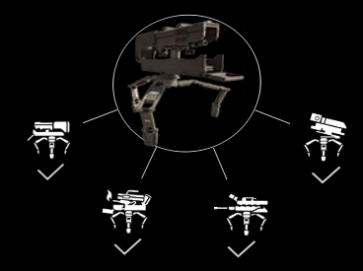 | 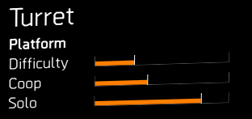Deployed skill that on mouse & keyboard readies with first press and thrown out with a second, and instant used with a double press or keybind.  and on a controller it will instant use with a single press, and thrown with a long press.  Deploys on top of the cover that you are attached to with instant use.  Deploys turrets that do different things per variant.  Can be picked up from the ground by standing near it and holding the button it is on.  Can be deconstructed with a long held press of the button it is on.
Assault Turret | Targets and automatically fires at enemies in line of sight. Deals ballistic damage that scales with skill damage.
Incinerator Turret  (Fire Turret) | Turret that deploys and can fire in a cone, has special control for direction while ready-ing, can be turned on or off once deployed. Damage scales with skill damage and status effect, fire duration scales with status effect. Operating duration scales with skill duration. Special interaction with the Ortiz: Exuro gearset.
Sniper Turret | Deployed turret that is aimed by the player, will track players aimpoint, will fire with button press and has a set amount of ammo, can aim for headshot which will have a 2x multiplier. Deals ballistic damage that scales with skill damage (does not scale with players Headshot stat)
Artillery Turret  (Mortar) | Deployed turret that is aimed by player, will target ground where player is aiming with a circle, fires with a button press and has a set amount of ammo. Can be locked onto an area with a double press. Deals explosive damage that scales with skill damage and explosive damage.
All turrets are usable, with the assault being the mainstay of turret drone builds, incinerators working well with Exuro builds. And the artillery turret being the best explosives skill overall. The sniper turret can be useful for rain, but overall is outclassed.

Hive
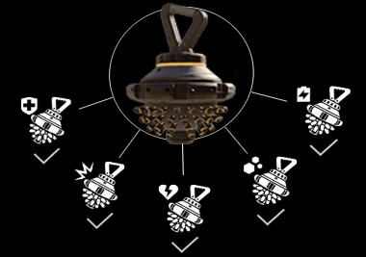 | 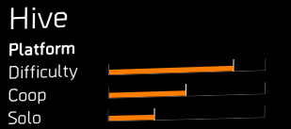Deployed skill that on mouse & keyboard readies with first press and thrown out with a second, and instant used with a double press or keybind.  and on a controller it will instant use with a single press, and thrown with a long press.  Deploys hives that do different things per variant.  Can be picked up from the ground by standing near it and holding the button it is on.  Can be deconstructed with a long held press of the button it is on.  Each variant works with charges that are consumed when used to do the variant's action.
Restorer Hive  (Healing Hive) | Heals player and allies that are within range and line of sight. Healing scales with repair skills.
Stinger Hive | Damages enemies that are within range and line of sight, applies bleed. Damage scales with skill damage, but NOT with explosive damage. Bleed scales with status effect.
Reviver Hive | Revives players. Will auto deploy for the player carrying it when downed. Can be used for others by throwing it near them. Will revive both downed and unconscious players.
Booster Hive | Boost player and allies that are within range and line of sight. Boost applies both weapon handling and hazard protection when active.
Artificer Hive | Targets skills that are within range to buff. Buff increases the main stat of skills and heals damage and duration of deployed skills. if deployed will send charges to skill in range and line of sight. If not deployed it will send charges to player’s skills and nearby handheld skills of allies. Can be used on the undeployed and on the players back, in that state even without charges.
All hives are great and have a great interaction with the BTSU gloves. Restorer is used with FI and combat medics. Stinger is a great tool for eclipse and skill damage builds. Reviver is a must for many red builds. Booster hive can be used for extra handling and is used for shenanigans with its hazard protection. Artificer hive is gear for skill builds and a core component of techtanks.

Chem Launcher
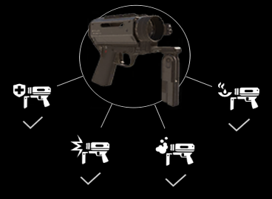 | 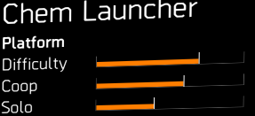  Handheld launcher that fires a charge with varying effects, first button press readies the launcher with a second press firing the charge.  Instant use is only available for reinforcer chem and does not do anything for the others.  Has a prediction overlay when readies that will show where the chem is expected to land.  Has charges that can be used separately.
Reinforcer Chem Launcher  (Healing Chem) | Heals player and allies, and has a burst heal that only applies to allies, burst also has a hidden short cooldown. Healing scales with repair skills, cloud duration scales with skill duration.
Firestarter Chem Launcher | Fire a chem charge that deploys a gas cloud. Gas clouds can be ignited by shooting them and by double tapping the button the chem launcher is on. Initial detention scales with skill damage, fire damage scales with skill damage and status effect, fire duration scales with status effect. (skill duration only affects the amount of time the cloud is in the game world.)
Riot Foam Chem Launcher | Fire a chem that foams enemies, foam duration scales with status effect.
Oxidizer Chem Launcher | Fires a chem that does corrosive damage. Damage scales with skill damage, and cloud duration scales with skill duration.
All chem launchers see some use. Reinforcer is a mainstay of healing builds. Firestarter is core for fire eclipse, while foam is core to foam eclipse. Oxidiser can situationally be one of the best damage dealers.

Firefly
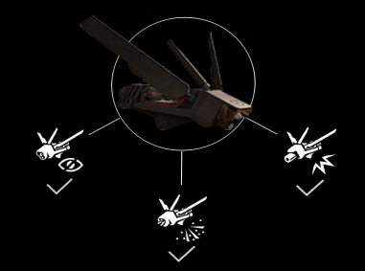 | 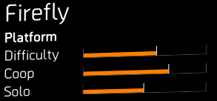  Thrown skills that will target enemies.  Will be readied with one button press and thrown with a second.  Has an overlay that targets enemies while readied and can target multiple enemies.  Once thrown will be an in-world object and can be hacked or shot.
Blinder Firefly | Applies blind to enemies. Blind duration scales with status effect.
Burster Firefly | Applies a detonation charge to enemies that will ignite if 2 or more enemies get close to each other, if any enemy triggers the explosion, all charges will ignite. Explosion damage scales with skill damage and explosive damage.
Demolisher Firefly | Targets weak points and destroys them which will damage or disable enemies or their abilities.  Damage amount dealt to weak points scales with skill damage.
Blinder firefly is a good tool for status effect builds, while demolisher can be utilized even on a red for disabling certain enemies like warhounds. Burster firefly, while potent, is not worth the hassle to make it work.

Seeker Mine
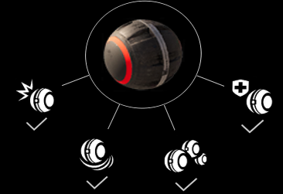 | 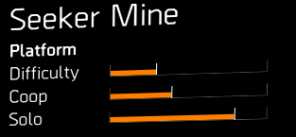Thrown skills that will target enemies.  Has differing control per variant.  Once thrown or deployed will be an in-world object and can be hacked or shot.
Explosive Seeker Mine | One large explosive seeker that can be thrown or deployed and then targets to a single enemy, deals damage in a radius, and applies bleed. Explosion damage is scaled with skill damage and explosive damage. Bleed scales with status effect.
Airburst Seeker Mine | Deployed with one press, targets an area with a second. Detonates on area dealing damage and creates a lingering fire damage area. Fire damage scales with status effect. Does not cross door boundaries.
Cluster Seeker Mine | Multiple small seekers that can be thrown or deployed and then targets multiple enemies. Each seeker has a radius and radii can overlap for more damage. Explosion damage is scaled with skill damage and explosive damage.
Mender Seeker Mine | Deployed seeker that heals player and allies, will roll around and try to heal wherever it can. Healing amount scales with repair skill.
Seekers are ok generally, they get overshadowed by other skills because of their lack of consistent damage. Clusters are great with hardwire seeker spam builds. Airburst can be used with eclipse as it is the longest fire but is often awkward to utilize. Explosive seeker is not enough damage to be useful and the mender seeker tends to not be great for healing oneself or allies.

Drone
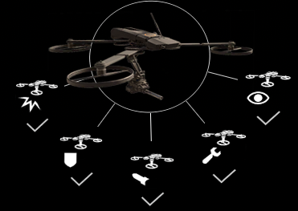 | 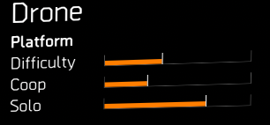  Activates a Drone that has several applications depending on the variant.  Single press activates and each variant had differing controls afterwards.  Once activated it will be an in-world object and can be hacked or shot.
Striker Drone | Drone that seeks out and damages enemies. can be targeted onto enemies with a button press. Can be recalled to player with double press. Deals ballistic damage that scales with skill damage
Defender Drone | Drone that activates and guards player from incoming damage,can be targeted onto allies. Can be recalled to player with double press. reduces incoming damage by a percentage.
Bombardier Drone | Drone that can carpet bomb an area, first press activates the drone, second press marks starting point and third press marks ending point. On third press the drone will carpet bomb the designated area. Explosion damage scales with skill damage and explosive damage.
Fixer Drone | Drone that heals player or allies, on button press activates and heals player,can be targeted onto allies with button press. Can be recalled to player with double press. Healing scales with repair skill.
Tactician Drone  (Recon Drone) | Drone that can spot enemies and can be designated an area to linger and continuously spot enemies. First button press deploys, second button press designates area to spot. Can be recalled to player with double press.
Striker and tactician drones are great. Striker drone is the other mainstay of turret drone builds. Tactician can be used for mmr builds for vision and is great for hotshot. Defender sees some use in pvp. The fixer drone is not enough healing to be really useful, and the targeting mechanic of the bomber drone makes it close to unusable.

Ballistic Shield
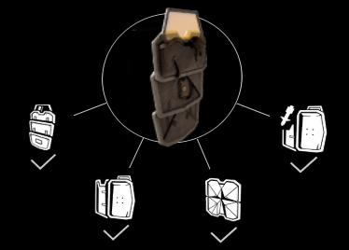 | 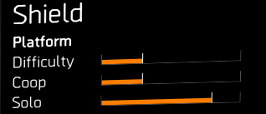Handheld shields that guard players from damage in a cone in front of them. Deploys with the first button press and is stowed with a second button press.  Crusader and Striker shields can be used with ARs, SMGs, Rifles, Shotguns and pistols  Bulwark and Deflector shields can only be used with Pistols.  Shields are categorized as Health and are affected by DTH and are weak against explosive damage.  All scale with skill health.  Gains Skill tier from Blue Cores.
Bulwark Ballistic Shield | Large shield with large amount of health.
Crusader Ballistic Shield | Small shield with moderate health.
Deflector Ballistic Shield | Small shield that deflects incoming fire back to a target, when aiming down sights has an overlay to target specific enemies, can reflect friendly fire as well. Damage scales with skill damage.
Striker Ballistic Shield | Small shield with the same health as crusader. Has a damage buff against enemies within its forward cone, which applies to the player, and to allies standing within its rear cone. Allows for use of firewalls flamethrower while activated.
Bulward, crusader and striker shields are great. All three see use in general red builds, bull wark goes well with regulus or d50 builds, where crusader and striker are an easy extra health buffer for redbuilds in general. And with them scaling with armour cores they are the go to if you have any blue cores. Deflector shield is generally not worth the hassle to make it work.

Disruption and Hacking
Disruption is a status effect that can disable your skills and disable or destroy deployed skills. The common sources are jammer effects by EMP jammers, sniper warhound explosions or hunters.
Being a status effect it can be shortened with hazard protection or completely bypassed with high enough hazard or disrupt protection. Hazard/Disrupt protection has no transitive properties towards deployed skills, handheld and personal skill do benefit.

Hunters & Descent Nemesis’s have the ability to hack SHD skills, they do so with an action, hijacking the skills and turning it on the player. Therefore one should always watch out with deploying skills that are either deployed or have an inworld presence, as they can be hacked and hijacked, especially during countdowns’s initial parts and extraction. Handheld and personal skills cannot be hacked by them.

Keener has a special version of hacking, which will work even if no skills are deployed. If he gets his hack off, skills on players will trigger and also become damaging variants. For instance revive hives become hacked stinger hives, healing chems will become hacked oxy chems, etc. One way to mitigate this is to take skills that have no damaging variants like pulses, decoys or shields. One can also provide the faraday effect with the remote pulse to avoid the shock, and even if hacked has no real danger attached as pulses have no damaging variant.

Faraday is a Perk from Technician that allows some deployed skills to provide nearby player and allies with disruption and shock protection. Any nearby player will have a blue line going from the skill to them, signifying that they are protected. The skills that can provide faraday are : all the turrets, all the hives, and the remote pulse.

Updating vs Non-Updating
Some skills continuously update their skill tiers while others will be a set number at the point when used/applied/deployed. For instance an assault turret will continuously update its damage according to talents such as In Sync or the Capacitor talent, while others like the fire applied from a fire chem will not.

The charges on skills like the hives will not continuously update once deployed, this can be important for deploying hives after supercharges, but also useful to use with the TDI Kard Custom’s +1 skill tier to get a temporary second charge out of a hive to revive others while keeping a charge for oneself.

Skills list and if they do or do not auto update post deployment or triggering, both for skill tiers and for talents :
- Smart Cover : Does NOT update skill tiers, will snapshot skill tier on deployment, skill tier indicator incorrectly indicates that it is auto updating, but testing shows otherwise.
- Sticky Bombs : Do not update skill tiers post launch, do update damage for talents. Fire sticky does not auto update fire dmg.
- Traps : Do not update skill tiers post deployment, do update damage and status effects for talents. do update overcharged state.
- Decoy : Does update skill tiers to whatever skill tier the player is currently on.
- Pulses : Remote pulse auto updates skill tiers, others do not.
- Turrets : All turrets auto update skill tiers, including increasing ammo count post deployment. Update damage for talents post deployment. Incinerator turret fire dmg does not auto update.
- Hives : All hives auto update skills tiers and for talents, no hives will auto update charges post deployment. Bleed from stinger does not auto update post application.
- Chem Launchers : Foam and fire status effects do not auto update, repair and oxy do auto update post deployment.
- Fireflies : Do not auto update skill tiers post deployment, do update for talents.
- Seekers : Do auto update skill tiers and talents post deployment. Fire status from airburst does not auto update
- Drones : Do auto update skill tiers and talents.
- Shields : Do continuously update skill tiers and talents.

Deployed, World Presence and Personal
Deployed skills are skills that deploy within the game world and are a proxy that does not share player stats outside of yellow stats, meaning they benefit from skill damage and such, but not hazard protection or red stats. Deployed skills can be jammed or hacked, or be destroyed by enemies. Deployed skills can trigger perks like Faraday or talents like Overclock. Deployed skills are Traps, Decoys, Remote Pulse, Turrets and Hives.

World presence skills are skills that once triggered have a presence in the game world, they do not share player stats outside of yellow stats. World presence skills can be hacked, jammed or destroyed during the time they are an ingame world object. Skills that have world presence are Fireflies, Seekers and Drones.

Personal skills are skills that are either triggered or handheld, because they are not deployed or an in game world object they cannot be hacked (outside of keener fight), they do benefit from all player stats, including still being available even if normally jammed, if the player has high enough hazard/disrupt protection. The Shields also benefit from stats such as Protection From Elites. Personal skills are triggered skills such as Pulses and Shields, and handheld skills like the Stickies and Chems.

Door Boundaries
Door boundaries are protection mechanics that prevent some damage going across certain boundaries, mostly spawning areas of enemies, as an example, when multiple enemies come from a door with some still inside while others are already out, if you were to foam chem them, if the foam hit outside the door it would only foam the enemies outside, and if it hit inside it would only foam the enemies inside. Some skill can cross door boundaries such as the fire chem and oxy, making it possible to hit both sides at once. Generally explosive skills only hit one side of a door, and some automatic skills will not trigger until enemies exit their spawn door such as a stinger hive.

It is important to know what skills do and do not cross door boundaries,
- Smart Cover : Does cross door boundaries to affect allies
- Sticky Bombs : Do not cross door boundaries with effects or damage. Can be fired into spawn doors to hit only inside.
- Traps : Do not cross door boundaries with effects or damage. Cannot be deployed into spawn doors
- Decoy : Does affect enemies wherever they are without considering door boundaries.
- Pulses : Do affect enemies wherever they are without considering door boundaries.
- Turrets : Depends on variant if it does door boundaries. Assault does not target past door boundaries. Sniper can target and fire past door boundaries. Incinerator’s fire will not cross door boundaries. Artillery will not target past door boundaries, explosion will not cross door boundaries. Cannot be deployed into spawn doors
- Hives : Do not target past door boundaries. Cannot be deployed into spawn doors
- Chem Launchers : Fire and oxy can cross door boundaries. Foam can not cross door boundaries with foam effect. All can be fired into spawn doors. Foam can be fired into spawn doors to hit only inside.
- Fireflies : Do not target beyond door boundaries. Effects do not cross door boundaries.
- Seekers : Do not target beyond door boundaries. Effects do not cross door boundaries.
- Drones : Do not target beyond door boundaries. Effects do not cross door boundaries.
- Shields : Deflector does not target beyond door boundaries.

And a further explanation is giving in the following OnlyTips video:
[TODO make and link this damn video]

Scaling with other Stats
Damaging skills, With the exception of the ballistic skills, can benefit from Damage To Armour (DTA) with 2 skills also benefiting from Damage To Target Out Of Cover (DTTOOC), No Skills benefit from Damage To Health (DTH).
Most skills that deal yellow explosive damage benefit from explosive damage stat, with the exception of the Stinger Hive.
Consult the graphic, of unknown source, below for the full list.
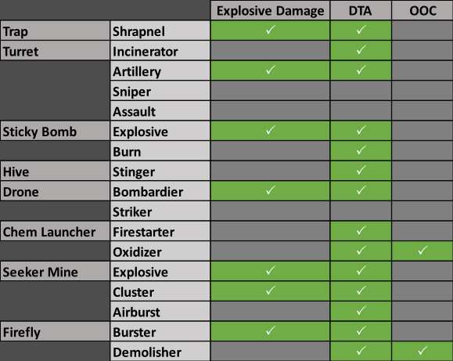

Expertise Grades
Each skill has proficiency and can once proficient also be expertise graded.
Each skill will benefit in different ways with some being more useful than others to put grading on.
Below is a graphic, by LJACK2K, with all of the stats that will be improved if you grade up a skill.
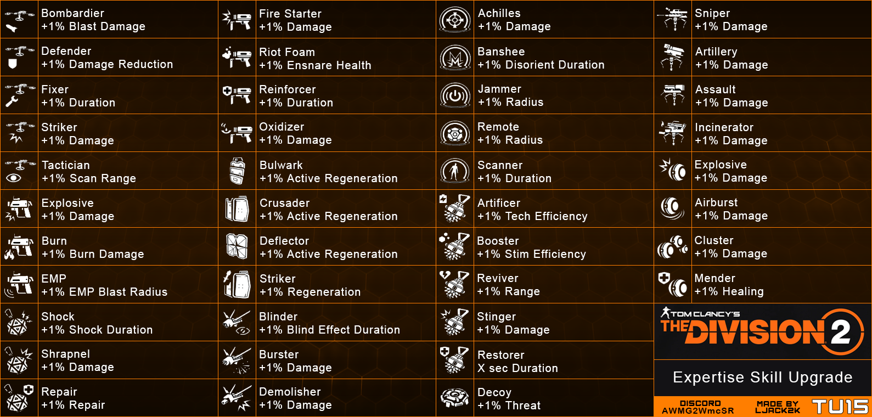

Skill Mod Tracker
I have made a skill mod tracking spreadsheet, which can be found here :
https://docs.google.com/spreadsheets/d/1DYid_mC2jMfJZW2oe1fjOmrKE7wSzCugARZUYQo8SDM
To use it, you will need to copy it to your own drive, and then you can input your values, also as a neat function, it will make the cell green if at max, or red if below the max value of that mod, letting you easily see which ones you need after filling it all in.
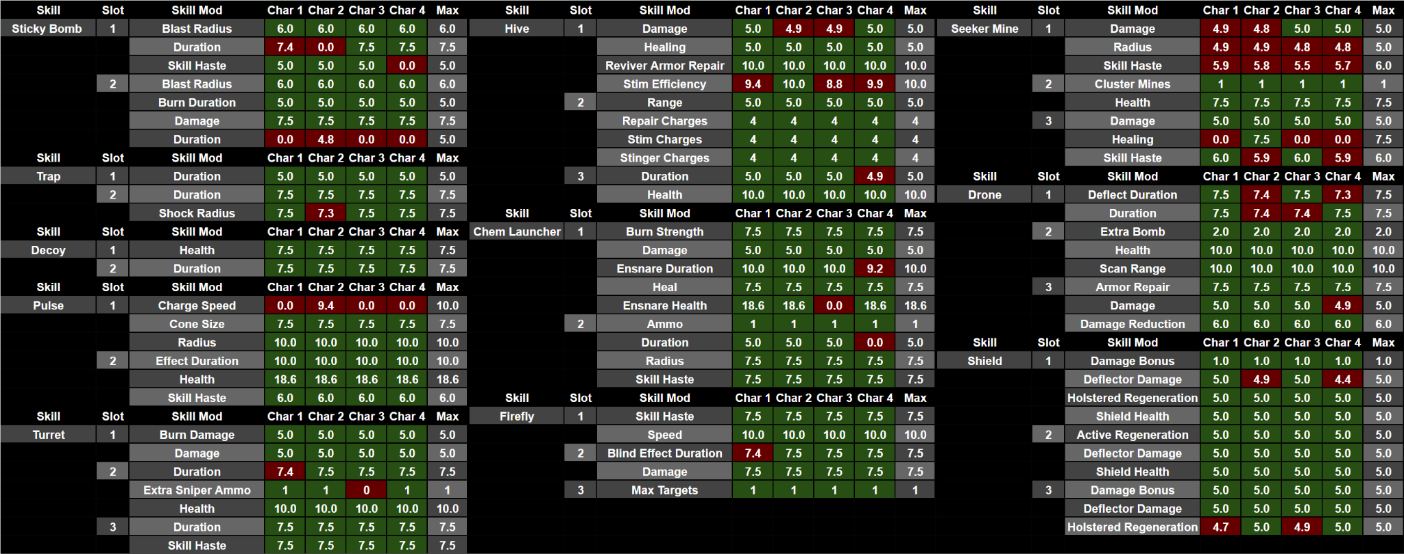

General Tips
- Ballistic skills that auto target (the assault turret and striker drone) will have diminished effectiveness in adverse weather. Rain, fog and sandstorms affect all ai including npcs and your tutter and drone, making them much worse for those times, sniper turret can be used as a replacement during those weather events, as it does not get affected by them.
- TDI Kard Custom can be used to get a quick extra skill tier, this in combination with hives not auto updating once deployed can be used to revive someone else while keeping a revive hive for yourself at 0 skill tiers. This is done by holding out the TDI Kard Custom, then tossing out the hive, and afterwards you can go back to whatever other weapon and even a 0 tier hive will have 2 charges.
- Placement and positioning can matter a lot for skills such as hive and turrets, for turrets you want them higher up if possible so they can fire with less obstructions. For the hive they do require line of sight to activate, and can be very useless if thrown poorly.
- Overcharge is one of the most powerful effects in the game, together with the BTSU overcharge being completely overpowered if used correctly, be sure to think about when you want to supercharge your team and do not just waste it because you don't want to run across a room to pick back up your hive. A well timed supercharge can turn the tide if used correctly.
- Supercharges from an ally's BTSU glove talent have a distinctive sound, if you are on the receiving end of it, be sure to make use of your skills. If you have a shield, that shield is invincible for the duration of the overcharge, if you have a pulse that can be used to debuff enemies for 15% extra damage for the duration of the over charge.
- The BTSU glove can even be used to provide a supercharge from a build with no skill tiers by using it twice, the first time it will overcharge the player themselves, which also makes you skill tier 6, if you do a second hive destruction in that time, you will supercharge the team.
- Parkers for skills that target enemies can be useful by themselves as they reveal enemy positions pretty well. The button popup for targeting enemies for a turret or drone can very easily be used to know where enemies are.
- Pulse effect upon enemies is not a status and does not get affected by status effect, pulse is its own category as it is also not considered a debuff.
- When using shields you should also pay attention to how high above or below enemies are, just as with them being too much to the left or right so they can hit you past your shield, it is the same for enemies higher and below you. Enemies on a building above you can just shoot you past your shield from above even if you are facing them.

Links to my other guides, the Build Collection, DMG/DPS Calculators and many other things:

https://docs.google.com/document/d/15mg-_sjowh5_8bUp2VIBqnDxCDqz-xJOISl0DlG3RDU

